1.3) a)

nx=[-3:7];
x=[0 0 0 2 0 1 -1 3 0 0 0];
stem(nx,x)

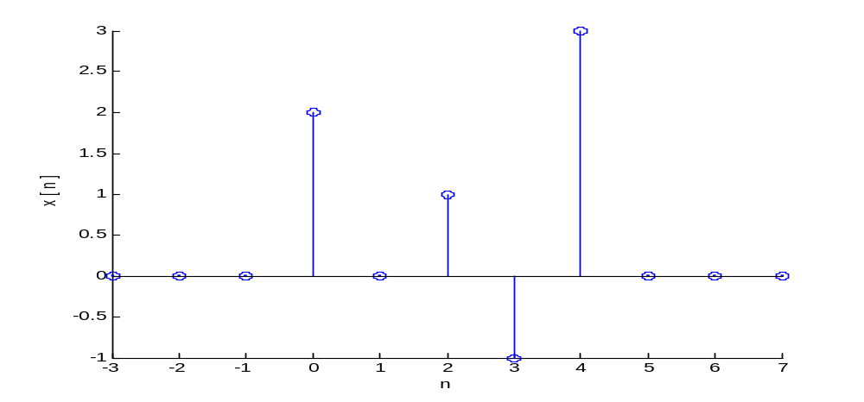

b)
nx=[-3:7];
x=[0 0 0 2 0 1 -1 3 0 0 0];
ny1=[-1:9];
ny2=[-4:6];
ny3=[-7:3];
ny4=[-8:2];
y1=x;
y2=x;
y3=x;
y4=x;

c)
nx=[-3:7];
x=[0 0 0 2 0 1 -1 3 0 0 0];
ny1=[-1:9];
ny2=[-4:6];
ny3=[-7:3];
ny4=[-8:2];
y1=x;
y2=x;
y3=x;
y4=x;
stem(ny1,y1)

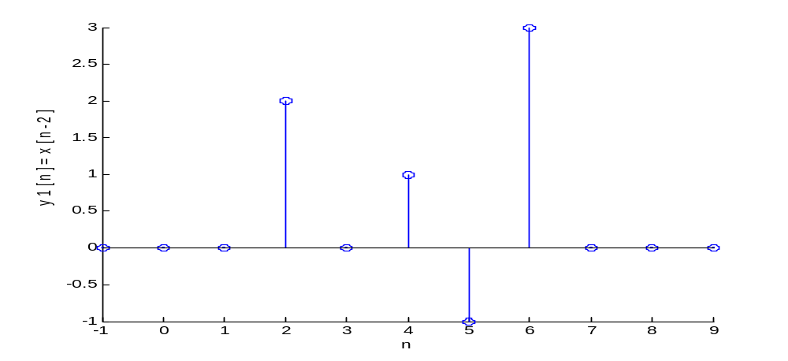

y2, y3, y4;

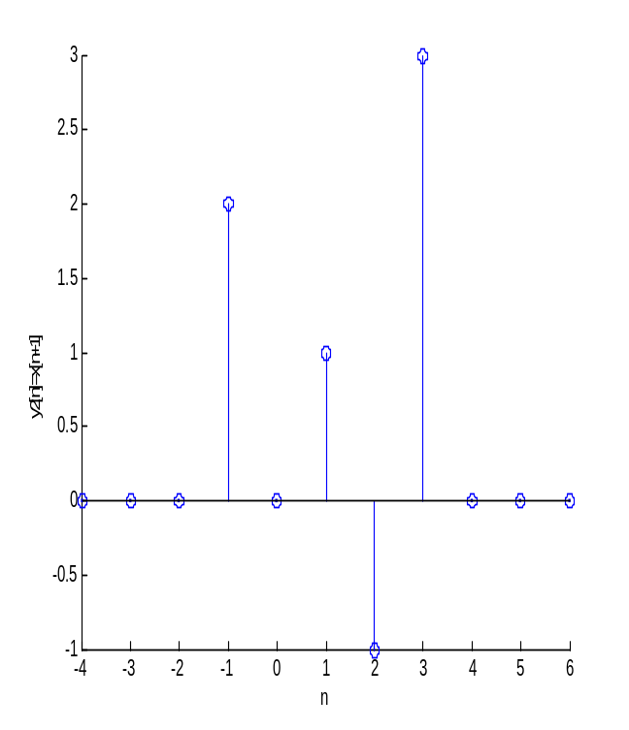
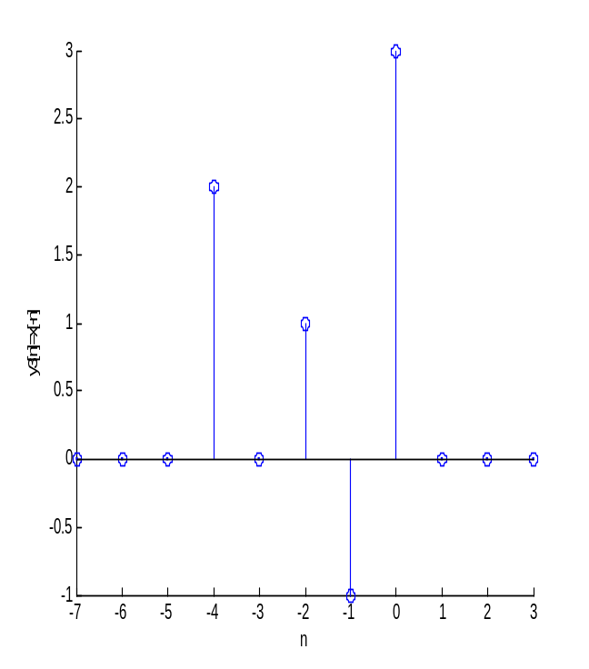

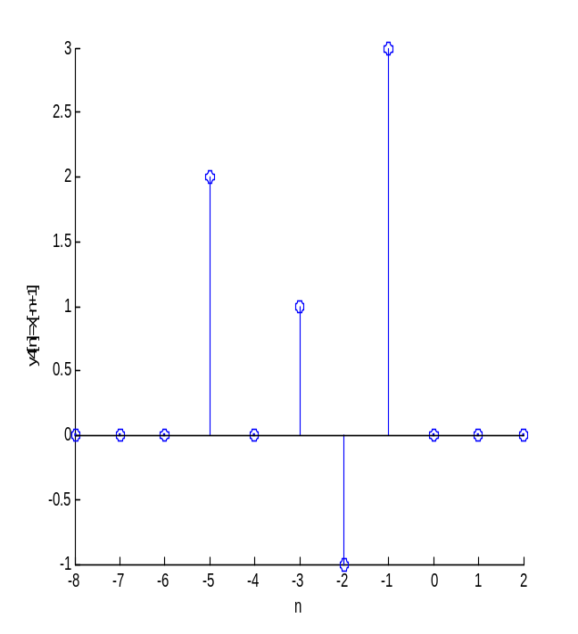

2.1)a)

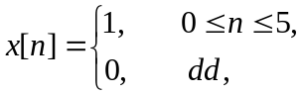

b)

n = [0:5];
x = [1 1 1 1 1 1];
y = conv(x,x);
ny=[0 1 2 3 4 5 6 7 8 9 10];
stem(ny,y)

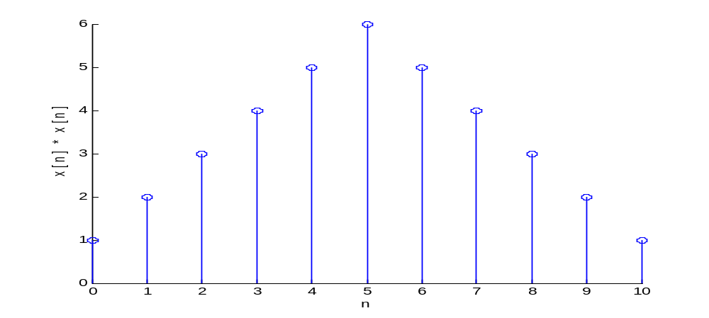

c)

n = [0:5];
h = n;
x = [1 1 1 1 1 1];
y = conv(x,h);
ny = [0 1 2 3 4 5 6 7 8 9 10];
stem(ny,y)

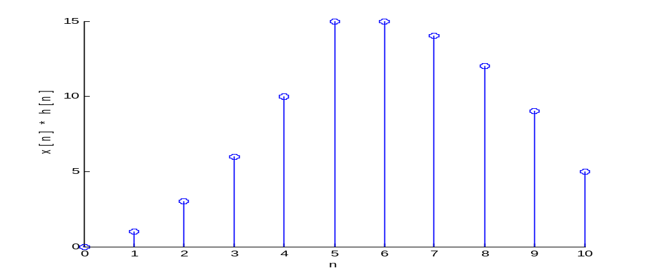

d)
n = [0:5];
h = [-5:0];
x = [1 1 1 1 1 1];
y2 = conv(x,h);
ny2 = [-5 -4 -3 -2 -1 0 1 2 3 4 5];
stem(ny2,y2)

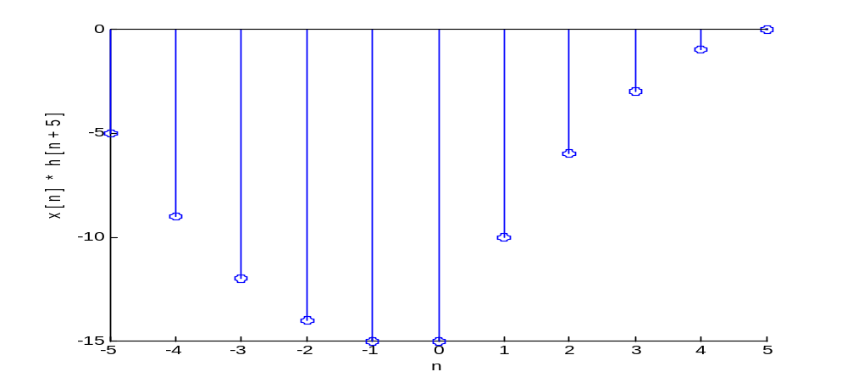

2.2)a)
a1 = [1];
b1 = [0.5 1 2];

b)
a2 = [1 -0.8];
b2 = [2];

c)
a3 = [1 -0.8];
b3 = [0 2];

d)
a1 = [1];
b1 = [0.5 1 2];
a2 = [1 -0.8];
b2 = [2];
a3 = [1 -0.8];
b3 = [0 2];
x = [1 2 3 4];
y1 = filter(b1,a1,x)
y2 = filter(b2,a2,x)
y3 = filter(b3,a3,x)

2.7)a)

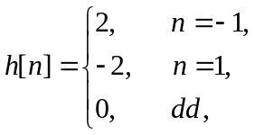
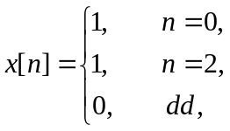

y[n] = x[n] * h[n]  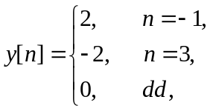

h = [0 2 0 -2 0 0 0];
x = [0 0 1 0 1 0 0];
ny = [-4:8]
y = conv(x,h);
stem(ny,y)

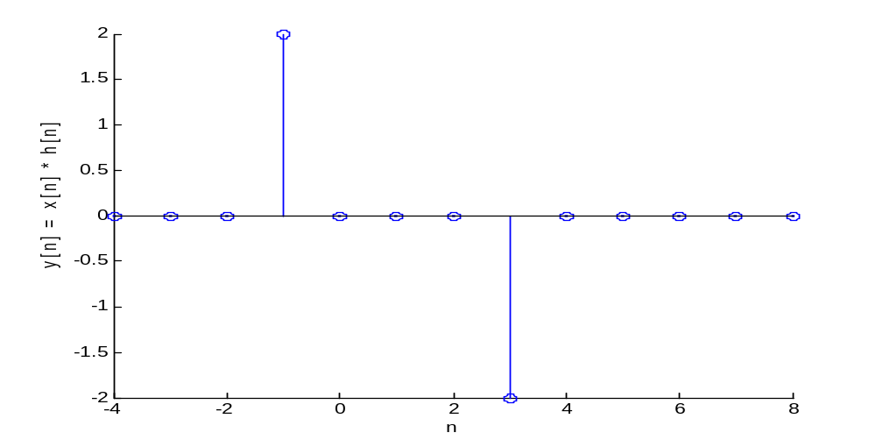

3.2) a)

>> a1=[1 -0.8]

a1 =1.0000 -0.8000 >> b1=[2 0 -1]

b1 =2 0 -1

b)

a1=[1 -0.8]
b1=[2 0 -1]
[H,W]=freqz(b1,a1,4)

a1 =1.0000 -0.8000

b1 =2 0 -1

H =5.0000
2.8200 - 1.3705i
1.8293 - 1.4634i
0.9258 - 0.9732i

W =0
0.7854
1.5708
2.3562

c)

a1=[1 -0.8]
b1=[2 0 -1]
[H,W]=freqz(b1,a1,4,'whole')

a1 =1.0000 -0.8000

b1 =2 0 -1

H =5.0000
1.8293 - 1.4634i
0.5556
1.8293 + 1.4634i

W =0
1.5708
3.1416
4.7124

4.2) a)

tau=0.01;
t = [0:tau:10-tau];
x= exp(-2*abs(t));

b)

>> t=[0:0.01:(10-0.01)];
>> y=exp(-2*abs(t-5));
>> N=10/0.01;
>> length(y)

ans =1000>> N

N =1000

